**NATIONAL INSTITUTE OF TECHNOLOGY**

**KURUKSHETRA**



**PRACTICAL FILE**

**SUBJECT :-** **Programming Using Python**

**BRANCH :- CS-A-01**

**ROLL NO :- 12112003**

**Submitted to:-**

**Shweta Pandey mam**

**Submitted by:-**

**Priyanshu maurya**

**Experiment-1**

1. Write a program that reads temperature in degree Celsius from console and converts it to Fahrenheit. Display the result. Formula for conversion is given as follows:

*Fahrenheit = (9/5) * Celsius + 32*

cel = float(input("Enter temperature in Degree Celsius :"))

far = 9*cel/5.0+32

print("Temperature in Fahrenheit ", far)

OUTPUT



1. Write a program that reads the radius and length of a cylinder, to compute the area and volume of the cylinder using following formula:

*Area = radius * radius * π*

*Volume = area * length*

height = int(input("Enter height of cylinder : "))

radius = int(input("Enter radius of cylinder : "))

area = math.pi*radius*radius

volume = area*height

print("Area of circular surface = ", area)

print("Volume of cylinder = ", volume)

OUTPUT

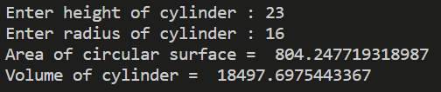

1. Write a program that reads a number in feet, converts it to meters, and displays the result. One foot is 0.305 meters.

feet = int(input("Enter length in feet :"))

meter = feet*0.305

print("Length in meters = ", meter)

OUTPUT



1. Write a program that reads a weight in pounds and converts it into kilogram. One pound is 0.454 kilograms. Display the results.

pounds = int(input("Enter weight in pounds :"))

kg = pounds*0.454

print("Weight in kilogram = ", kg)

OUTPUT



1. Write a program to find the sum of all the prime numbers less of equal to a given number.

n = int(input("Enter n upto which sum of prime numbers had to be calculated : "))

total_sum = 0

for i in range(2, n+1):

    f = 1

    for j in range(2, int(math.sqrt(i)+1)):

        if i % j == 0:

            f = 0

            break

    if f == 1:

        print(i,*end*=" ")

        total_sum = total_sum+i

print("\nTotal sum of all prime numbers less than equal to ",n," is ",total_sum)

OUTPUT

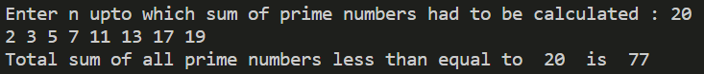

1. Write a program that calculates the distance between two points, where the coordinates of the points are provided by the user.

import math

x1 = int(input("Enter x cordinates of first point :"))

y1 = int(input("Enter y cordinates of first point :"))

x2 = int(input("Enter x cordinates of second point :"))

y2 = int(input("Enter y cordinates of second point :"))

distance = math.sqrt((x1-x2)*(x1-x2)+(y1-y2)*(y1-y2))

print("Distance between given 2 points : ", distance)

OUTPUT

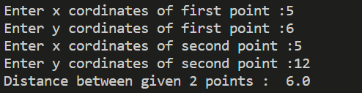

1. Write a program that calculates the energy needed to heat the water from an initial temperature to a final temperature. Program prompts the user to provide the amount of waters in kilograms and the initial and final temperatures of water. Formula for calculating energy is as below:

*Energy (in joules) = weight of water (k.g.) * (finalTemp - initialTemp) * 4184*

water = int(input("Enter amount of water(in Kg) :"))

intial_temp = int(input("Enter intial temperature :"))

final_temp = int(input("Enter final temperature :"))

energy = water*(final_temp-intial_temp)*4184

print("Energy needed = ", energy)

OUTPUT

